**ATTENDANCE BY QR**

**1: FE structure**

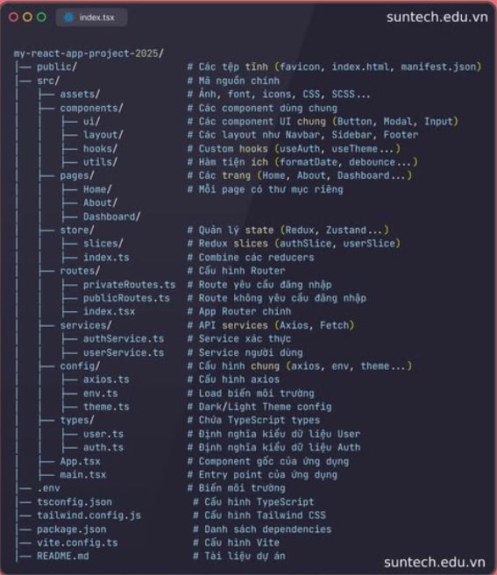

**2: Web API security**

